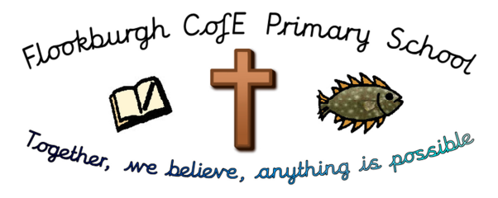
Flookburgh School News
17th May 2019

This term’s Christian Value is ‘Endurance’
‘You know that many runners enter a race but, only one of them wins the prize!
Corinthians 9:24

Headteacher, Framed and Busy Bee Certificates have been awarded to:
 | Headteacher | Framed | Busy Bee
Class 1 | Kaira Latham  Harvey Bennett | Sophie Rowlandson  Lottie Grimshaw | Edie Crowe  George Gribble
Class 2 | Archie Goodrum  Eleanor Tegg | David Appleton  Maddison Wadlow | Daniel Olerenshaw  Billy-Joe Coward- McSkimming
Class 3 | Nisha Gregson  Casey Evans | Oscar Rowlandson  James McClure | Dylan Benson  Alfie chapman
Class 4 | Year 6 | Samuel Rowlandson | Year 5
Ofsted December 2018 says,
‘This school continues to be Good’
Attendance Week Ending:
Friday 10th May 2019
Class 1 | 95.51%
Class 2 | 94.88%
Class 3 | 97.53%
Class 4 | 96.69%
Whole School: 96.31%

Lunchtime, Before and After School Activity Clubs for the 1st half of Summer Term
 | 8.45-9.00am | 12.30-1.00pm | 3.15-4.15pm
Mon | KS2 ‘Wake and Shake’ | Young Leaders | KS2 Craft, Design and Technology  KS2 Sports Club
Tues | KS2 ‘Wake and Shake’ | Y6 ‘Chatterbooks’ Reading Club
Wed | KS2 ‘Wake and Shake’
Thurs | KS2 ‘Wake and Shake’ | Running Club | Gardening/ECO Club
Fri | KS2 ‘Wake and Shake’ | Young Leaders

CLASS OF THE WEEK CLASS 2: Thankfully we are over the worst of the chicken pox and (almost) back to a full class in class 2. This week the Year 2's started their SATS papers and I have been very impressed with their hardworking approach; well done all of you - you definitely deserved those post-test biscuits! Our topic this term is The Victorians and this week we have been finding out what Victorian schools were like. The teachers were very strict and if you got your sums wrong, you might have had to stand in the corner and wear the dunce's hat. We all had a go at wearing a dunce's hat and decided that we are glad they don't exist in the classroom today! During our Science lesson, we took part in an outdoor treasure hunt. We had a go at identifying seeds, flowers, butterflies, mini-beasts, birds and more. We have also been busy tending to our seedlings, which are growing really well and have started to plant up some pots. We love learning outdoors and hope this sunny weather continues!
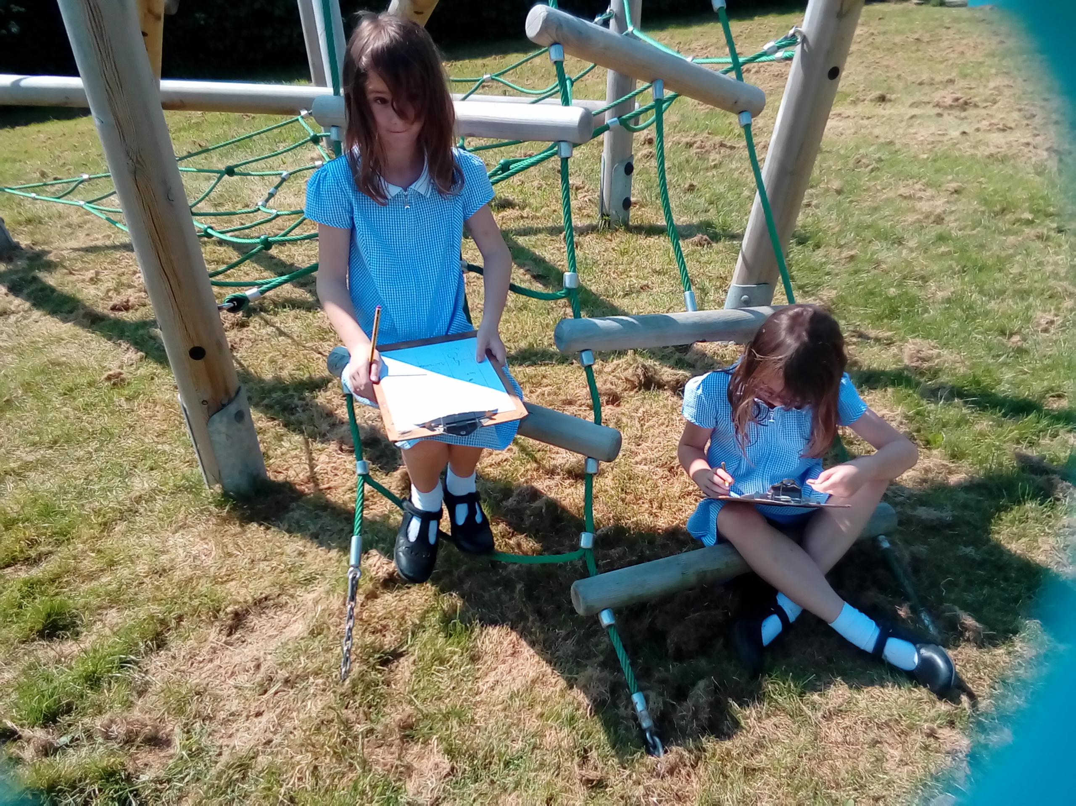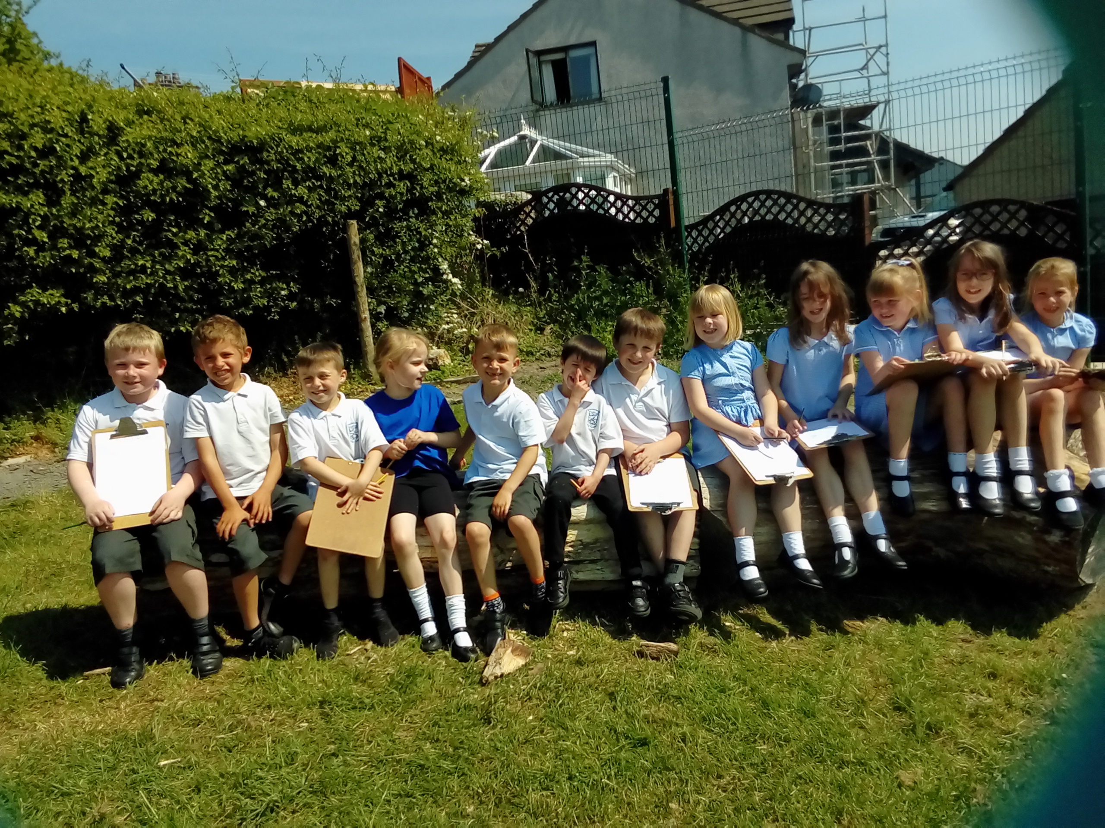
YEAR 6 SATs: The statutory assessments in Mathematics, Reading, Grammar, Punctuation and Spelling have finished this week; we are all extremely proud of our Year 6 children for their calm and determined approach to the tests – they are a real credit to themselves, the school and their families; well done from all of us.
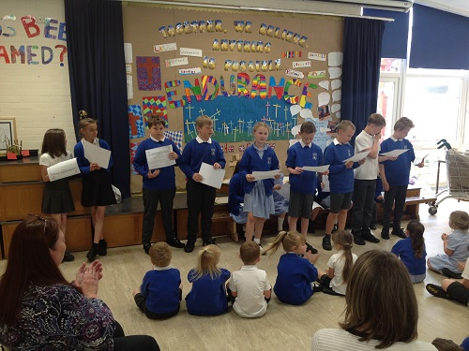
Please note, the Y6 Booster Classes have finally finished!
Work towards the Year 6 Writing Teacher Assessments however, continues until the end of June so, this will remain a focus over the next few weeks for the children.

Outcomes of the statutory assessments are notified to school around the beginning of July which will then be shared with parents and children in their end of year reports.
SPRING FAIR – THURSDAY 23RD MAY (2pm – 4pm): Our Spring Fair is fast approaching and we are all very excited about raising funds for our chosen charity, ‘Children of Hope’. Through the Values Group, the children in school would like funds from this term’s enterprise to go to support the education of children in Uganda. It is hoped that we will then donate a percentage of monies raised at future enterprise events to continue our support and link with ‘Children of Hope’.
The children throughout school are busy preparing items to sell on their stalls next week and we are all looking forward to seeing as many of our parents, extended families and the wider community coming along to enjoy the afternoon.
One of the stalls we would like to have is a ‘Bring and Buy’ Jumble Table – please could we ask that you take this opportunity to rifle through your cupboards and wardrobes for any unwanted gifts/out-grown, clean, clothes, etc to donate to the stall.
All items should be brought into the school hall in a clearly labelled black bin-liner from Monday onwards next week. Thank you!
THRIVING TROLLEYS COMPETITION at COUNRTY FEST: Gardening club have been busy preparing a supermarket trolley which we shall be filling with plants, vegetables and flowers for a competition at this year's Country Fest. The theme is 'Health and Happiness' and we have been very busy bringing all our ideas to life! The show takes place on the 1st and 2nd June where the trolleys will be on display and advance tickets at a discounted price are available on the website. A photo of the finished trolley will be in next week's newsletter and you are welcome to come into the quad area in Class 2 to take a look!
Mrs Morrell
YEAR 1 PHONICS SCREEN PARENT INFORMATION SESSION – TUESDAY 21st MAY: Mrs Morrell is holding an information session for parents of Year 1 pupils in Class 2 after school about the Phonics Screen Check which shall be taking place during the week commencing Monday 10th June. We hope that you will all be able to attend the meeting where Mrs Morrell will be able to explain the screen to you and answer any questions you might have.
YEAR 5 AND 6 RESIDENTIAL: A gentle reminder, the final payment date for this year’s residential is rapidly approaching. We have a few outstanding payments yet to come in; the full amount should be handed into the school office by Friday 24th May at the latest.
AFTER-SCHOOL ACTIVITY CLUBS AFTER HALF-TERM: Please can all children who would like to attend one of our after-school clubs, please sign-up directly with the Club Leader by Tuesday 21st May to enable us to prepare our registers, etc in time for the beginning of next half-term.
The teacher leading each club shall be sending a information home about their clubs, including which age-group(s), the clubs will be for. Thank you




Dates for your Diary for the Summer term:
Tues 21st May Individual and Family Photographs – All year groups
Tues 21st May Year 1 Phonics Screen Information Session for Parents in class 2 at 3.15pm with Mrs Morrell
Wed 22nd May Y5 and 6 Rounders Festival @ CPS 1 – 3pm – Details to follow
Thurs 23rd May Spring Fair in school – details to follow
Mon 27th May Half-term begins, ending on Friday 31st May
1st & 2nd Jun Thriving Trolleys competition at Country Fest – Flookburgh School Gardening Club have an entry in this year’s competition; they would love it if you could see their finished trolley – best of luck everyone!

Mon 3rd Jun Summer term begins
Tues 4th Jun YoKids Yoga begins again across the whole school
Ignite Club with Libby and Tonje begins again
5th – 7th Jun Class 4 Residential at Brathay
Mon 10th Jun Phonics Screening Tests carried out this week – details to follow
Thurs 13th Jun ‘Jester for Jesus’ Assembly with Mark and Sarah Callaghan
Mon 1st July Sports Day held in the morning from 9.15am
Mon 8th July Reserve Sports Day
W/c 8th July End of Year Reports out – date to be confirmed
Tues 9th July Year 6 SAT Results are confirmed to school today
Mon 15th July Whole School Parents Evening to discuss reports 3.30pm – 5.00pm
NB: We have not included any dates for competitions that we may be entering over the course of the Summer term; we shall notify you of events our children shall be competing in nearer the time.

Further dates for events and activities may be added to the diary as the term progresses so, please watch out for updates in the newsletters.
Internet Safety Link for your information and records:

https://www.ceop.police.uk/safety-centre
National Online Safety Details:
- www.nationalonlinesafety.com
- Twitter - @natonlinesafety
- Facebook - /NationalOnlineSafety
- Phone - 0800 368 8061

