
Flookburgh School News
26th April 2019

This term’s Christian Value is ‘Endurance’
‘You know that many runners enter a race but, only one of them wins the prize!
Corinthians 9:24

This week’s Headteacher, Framed and Busy Bee Certificates have been awarded to:
 | Headteacher | Framed | Busy Bee
Class 1 | Jake Airey | Deon Nyamai | Brooklyn Cowperthwaite
Class 2 | Nula Bushell-McKenny | Grace Wheatman | Archie Goodrum
Class 3 | Eva Bernas | Louis Bennett | Charlie Gribble
Class 4 | Oliver Pearson | Grace Atkinson | Jake Gibbons

Ofsted December 2018 says,
‘This school continues to be Good’
Attendance Week Ending:
Friday 19th April 2019
Class 1 | 97.01%
Class 2 | 96.78%
Class 3 | 97.54%
Class 4 | 96.46%
Whole School: 97.01%

Lunchtime, Before and After School Activity Clubs for the 1st half of Summer Term
 | 8.45-9.00am | 12.30-1.00pm | 3.15-4.15pm
Mon | KS2 ‘Wake and Shake’ | Young Leaders | KS2 Craft, Design and Technology  KS2 Sports Club
Tues | KS2 ‘Wake and Shake’ | Y6 ‘Chatterbooks’ Reading Club | Y6 Booster Class
Wed | KS2 ‘Wake and Shake’
Thurs | KS2 ‘Wake and Shake’ | Running Club | Gardening/ECO Club  Y6 Booster Class
Fri | KS2 ‘Wake and Shake’ | Young Leaders
CLASS OF THE WEEK CLASS 3: This week was Class 3s first week swimming, and what a fantastic session we had. Unfortunately, we cannot take photographs inside the pool area, but if we could there would be lots of happy faces! They were a credit to the school with their behaviour and everybody tried their hardest with everything that was asked from them. This year, we have split into 2 groups so that children can work to certain awards in relation to their abilities in the water. I was so proud of the Year 3 cohort who showed fantastic courage and determination, even though they had never been swimming with us before. It was great fun, even I got in the pool for a quick splash! Well done Class 3!
EASTER SERVICE: A huge well done to all of our children and staff for their hard work and preparation for the Easter Service on Thursday 18th April and, of course, to all of our parents who were able to join with us to celebrate this greatly significant event in Christian calendar.
EASTER EGG COMPETITION: A huge well done to all of our children who entered our Easter Egg competition.
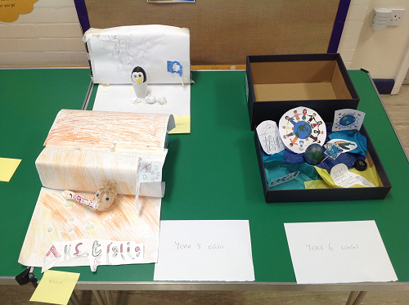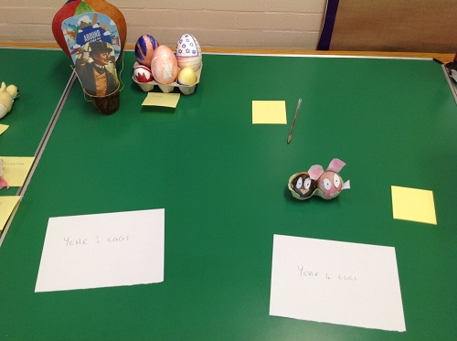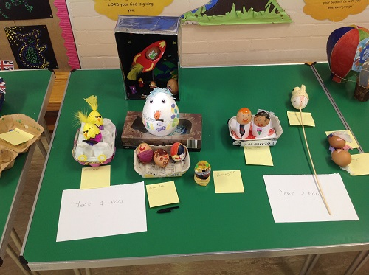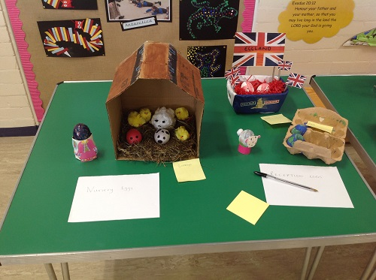
Our year group winners were:

Nursery: Annie Porter; Reception: Jake Airey; Year 1: Zac Walton; Year 2: Ava Porter
Year 3: James McClure; Year 4: Jacob Burrow; Year 5: Ellis Darwick; Year 6: Oliver Pearson

Thank-you to FOFs for providing the Easter Eggs for our competition winners and for hosting the raffle at the Easter Service.
YEAR 5 AND 6 RESIDENTIAL PARENT MEETING TUESDAY 7TH MAY: An update meeting for all parents regarding the planned Year 5 and 6 residential to Brathay in June will be held after school from 3.15pm until 4pm approximately in Class 4. During the meeting we shall be talking about the activities, accommodation and kit that shall be needed for the residential, as well as, answering any queries that you might have; we look forward to seeing you.
SCHOOL VISION STATEMENT UPDATE: Over the year we have been working with the children to develop our school Vision and our Vision Statement. Mrs Morrell has worked closely with the Values Group and subsequently with all the children throughout school to gather their voice and opinions. Following a lot of work, we have worded our Vision Statement based on our strapline, ‘Together, we believe, anything is possible’ which was originally based on Matthew 19:26 which reads, ‘With God, all things are possible’.
Our Vision Statement is…
‘To believe and trust our actions will inspire our community to be champions of their own destiny knowing that they have been empowered by God to make a positive difference for their own futures and for future generations to come’
Our Vision Statement is put into ‘child speak’ in the classrooms but, the underpinning message is the same!
We would all like to thank the children for all of their ideas and their belief in themselves to be the best that they can be and how much they value their community; we hope that you will agree our Vision Statement reflects how our children see themselves, their community and their school.
HOLIDAYS DURING TERM-TIME: Just a gentle reminder that holidays during term-time are actively discouraged due to the significant impact that holidays taken during this time can have on your child’s education; holiday requests, unless they are covered by certain exemptions, cannot be authorised.
During the Summer term, in particular, all of our children will be taking assessments, whether Teacher Assessments or Statutory Assessments. Year 1 will be taking their Phonics Screen at the beginning of June; our Year 2 will be taking their SATs throughout May with vital Teacher Assessment continuing into June and our Year 6 pupils will sit their SATs in May and will be working toward their teacher assessed Writing outcomes throughout June. As you can see, it is vital that children attend school to ensure that they are prepared as much as possible and they have the confidence to give of their best.
Assessments are part of school life and we do everything we can to ensure that children approach them calmly and without anxiety. We are grateful for the support you give to your children during this time, in particular, and the trust that you place in us to enable them all to succeed and achieve the best that they can.
SWIMMING FOR YEARS 3 – 5: Swimming for Years 3-5 has started this week; there are 5 sessions in total with the last session on Wednesday 22nd May.
KARATE SESSIONS KS2: Throughout the Summer term all of our KS2 children shall be taking part in Karate lesson on a Monday afternoon – please make sure that your child has their full PE Kit in school with them; there is no special clothing required.
The sessions shall continue for 9 weeks the aim of which is for your child to receive their first belt in karate!
YEAR 5 WATERSPORTS TASTER SESSION – FRIDAY 3RD MAY: Please not the change of date.
We are really excited about taking part in this two-hour long session at Windermere Outdoor Centre; the children have chosen sailing as their activity, depending on the weather ie we need at least some wind! If sailing can’t be done, their second choice was raft-building.
Further information regarding what the children will need for the morning ie clothing, shall be sent out to you shortly however, children will definitely need to have a packed lunch that day.
All of their adventures shall be shared with you as soon as we can so, please watch this space!




Dates for your Diary for the Summer term:
Mon 29th Apr KS2 Karate Sessions begin
Fri 3rd May Year 5 Watersports Development Day – Please note the change of date; further details to follow
Mon 6th May May Bank Holiday Monday – School closed
Tues 7th May Year 5 and 6 Residential Parent Meeting in Class 4, 3.15pm - 4.00pm – details to follow
Year 3 and 4 Dance Taster session with ‘Dance Attack’
Wed 8th May Reception Hearing Screening in school
Thurs 9th May ‘Jester for Jesus’ Assembly with Mark and Sarah Callaghan
Mon 13th May Year 6 Statutory Assessment Tests begin finishing on Thursday 16th May
Tues 21st May Individual and Family Photographs – All year groups
Thurs 23rd May Spring Fair in school – details to follow
Mon 27th May Half-term begins, ending on Friday 31st May
Mon 3rd Jun Summer term begins
Tues 4th Jun YoKids Yoga begins again across the whole school
Ignite Club with Libby and Tonje begins again
5th – 7th Jun Class 4 Residential at Brathay
Mon 10th Jun Phonics Screening Tests carried out this week – details to follow
Thurs 13th Jun ‘Jester for Jesus’ Assembly with Mark and Sarah Callaghan
Mon 1st July Sports Day held in the morning from 9.15am
Mon 8th July Reserve Sports Day
W/c 8th July End of Year Reports out – date to be confirmed
Tues 9th July Year 6 SAT Results are confirmed to school today
Mon 15th July Whole School Parents Evening to discuss reports 3.30pm – 5.00pm
NB: We have not included any dates for competitions that we may be entering over the course of the Summer term; we shall notify you of events our children shall be competing in nearer the time.
Further dates for events and activities may be added to the diary as the term progresses so, please watch out for updates in the newsletters.
Internet Safety Link for your information and records:

https://www.ceop.police.uk/safety-centre
National Online Safety Details:
- www.nationalonlinesafety.com
- Twitter - @natonlinesafety
- Facebook - /NationalOnlineSafety
- Phone - 0800 368 8061

